Loose teeth
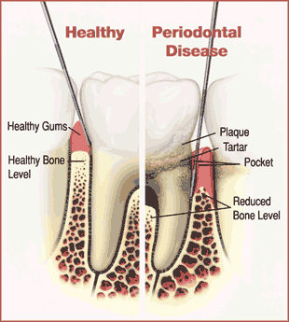
Teeth are held in the jawbone by a ligamentous tissue (periodontal ligament) that attaches the root of the tooth to the bone. The gum covering protects the whole area from bacterial invasion.
Any breach in the gum covering will allow bacteria to invade the ligament and destroy it by secreting powerful enzymes and toxins, this is followed by erosion of the bony socket that encases the tooth root. The result is looseness of the tooth and it's eventual loss.
The main reasons for the above are:
Gum disease: Gum disease (or Periodontal disease) is a preventable condition which results from plaque accumulation in between and around the teeth. Effective plaque removal techniques; when practiced well, effectively prevent and reverse the effects of gum disease. So; if you have loose teeth; attending our "Ace Gums Clinic" could be the answer. Gum treatment and effective home care could reverse the condition and even may save your teeth from eventual loss.

Bite problems: If you have few remaining teeth; even without gum disease; the loads that the remaining teeth have to bear to sustain normal function are far greater than their physiological tolerance; hence they start to loosen under the load and eventually are lost; further reducing the number of present teeth and you enter a vicious cycle where you run the risk of losing all of your remaining teeth.
Loose teeth which cannot be treated could be removed and replaced with Dental Implants (link) or bridges (link).
So; if you have loose teeth; and you do not want to lose them; you need to call us as soon as possible to arrange a free consultation.
You can download our free factsheet on gum disease and it's prevention here. Also you can sign up to our free newsletter to free information about dental health.

Loose dentures
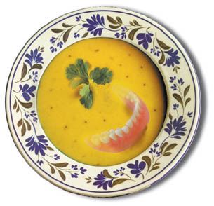

Do you wear full or part dentures?
Are you finding it difficult to taste and chew food with the dentures in place?
Are you becoming selective in what you eat?
Would you like to eat an apple, or perhaps a good piece of steak without cutting it to very small pieces?
Have you been wearing them for a long time?
Are they moving and hurting when you chew?
Do you have to clean them very often after meals as they trap food?
Are the falling out when you talk or laugh?

Dentures are a good replacement for missing teeth; however; the gums continue to shrink underneath and this leads to loosening and movement during function. This movement causes pain and discomfort as the delicate tissues underneath are nipped and squeezed.
Replacing or relining loose dentures could make them slightly more retentive; however; this could be short lived as the gum and bone continue to shrink.
Using adhesives could help too; however there is no ideal adhesive and may
Stabilising the dentures with dental implants could be the solution for you. Dental implants could be used simply to dramatically improve the stability of your denture during function; especially the lower denture. Dental implants could also be used to convert your denture into a fixed bridge in one day!!! This is the latest and most advanced development provided that you are suitable.
So why not find out how we can help you get rid of your denture problems by booking a free consultation..yes it will cost you nothing to find out.
You can sign-up to our free newsletter and receive regular free information about dealing with loose dentures. You could also e-mail us to request a free factsheet about stabilizing loose dentures.

Getting rid of tooth sensitivity

Do you have sensitive teeth?
Do your teeth hurt when you eat or drink anything that is not at room temperature?
Do your teeth feel sensitive when you brush them?
If the answer is YES; please read on.
Tooth sensitivity could be mild; moderate or severe. It is an irritating condition that interferes with eating and drinking anything which is not at room temperature.
Sensitivity has many causes (link to sensitive teeth); however; getting rid of sensitivity depends on the cause. When the cause is established; treatment could be started that would get you rid of sensitivity for good.
We can help you get rid of tooth sensitivity by applying some materials to the sensitive part of your tooth which seal the little pores that lead to the nerve.
Advice on the correct tooth brushing technique and correct homecare could reduce sensitivity as well.
If you would like to get rid of tooth sensitivity without relying on sensitive toothpastes; book a free consultation now; or sign-up to receive our regular free newsletter and also download free factsheets about how to prevent tooth sensitivity.

Teens Teeth

At the age of 13, all the adult teeth except wisdom teeth will have come through in most cases. The main issues which affect teenagers' teeth are the following: Crowding and discolouration.

Crowding is treated with braces and in some cases may involve extraction of teeth to create room to move teeth and straighten them. Braces are traditionally the "train track" ugly Betty-type; which could make some teenagers refuse treatment. However, at Smile Lincs we provide Invisalign invisible braces; these are transparent positioners which are nearly invisible.

Discolouration is treated by deep polishing which is a special way of removing stains and abrasion followed by polishing to a high luster; or whitening after the age of 16 (whitening is not suitable for under 16 year olds). Severe discolouration is treated by bonding a white material to the front of the teeth without any damage to the tooth enamel, and polishing it to a high luster. Bonding lasts for many years. Porcelain veneers (Lumineers or Future veneers) which are again applied without any tooth preparation; could be provided after the age of 16 as a more permanent solution with or without whitening.
Please sign up to our free newsletter to receive regular information, you could also request free factsheets about teenagers' dental health.

